Module 4 COMMUNICATIONS
Grammar: sequence of tenses, reported speech.
Word formation: prefixes tele-, trans-, inter-; adjective suffix able(ible)
Essential vocabulary
allow v attractive adj capable adj during prep either adj/conj | enable v entertainment n  evolve v  go on v  in particular adv | notify v occur v ongoing adj origin n precursor n | relatively adv  rely on v report v/n research n/v | require v  responsible adj  search n/v  simultaneously adv | solve v  take place v  through prep though prep trace n/ v transmit v
4. 1. Communication technologies
1. Look at the photos and say what communication technologies they show. Then write them under each picture.
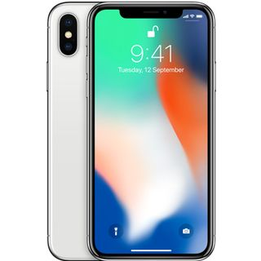  1________________ | 2_________________ | 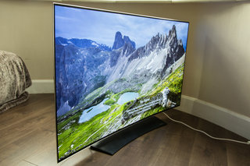  3________________ | 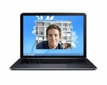  4_____________
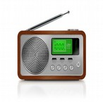5_______________ | 6_______________ | 7________________ | 8______________

2. Watch the video “From Stone Age to Tech Age: The Big Ideas that Shaped History”.
Tick the things that are mentioned in the video.
https://www.youtube.com/watch?v=u43zr_7Y0ts
- fax machine  - printing press  - telegraph  - first pager  - type writer  - smoke signals  - pigeon post | - telephone  - cell phones  - personal computers  - radio  - TV  - the Internet  - 3G and 3G technology

3. In pairs discuss the following questions:
1. How did people communicate in ancient times?
2. Who invented the printing press?
3. What is considered to be the beginning of the wired era?
4. Is there dispute as to the original inventor of the telephone? What do you know about it?
5. Who really invented the radio?
6. What technological invention caused a boom in the 1950s?
7. When were the first personal computers sold to the public?
8. Which technologies allowed us to communicate at light speed from anywhere on the globe?

4. Select your personal favourite piece of technology and describe it.
You should say:
- what it is (printing press, telegraph, telephone, radio, TV, the Internet, mobile phones etc.)
- what a man can/could do with it (a man can/could transfer…, is/was used to distribute news and literature…, as a way to send…)
- how often it is/was used (every day, sometimes, not everyone can/could use it)
- and explain why you think it is/was useful (that’s (the reason) why, due to (the fact that, it helps/helped people …, it allowed people to…)

Grammar
5. Revise Simple, Continuous, Perfect forms of verbs. Complete the questions with the correct forms of the verbs in brackets. Then work in pairs asking and answering questions.
1 Do you prefer TV, radio, books or the Internet? Why? (prefer)
2 _________you_____________ anything at the moment? What? (read)
3 _________you_____________ anything interesting recently? What? (read)
4 _________ you ____________ a TV series at the moment? Which one? (follow)
5 _________ you ____________watching TV from other countries? Give examples. (like)
6 _________you ____________ any important news today? What? (hear)
7 _________ you ____________anything good on TV last week? What? (see)
6. Complete the sentences with the correct form of the verbs in brackets.
A new survey in Britain ___________ that young people spend over 27 hours a week online (reveal). This figure ______ _________ in the past decade (treble). Britain's communications watchdog Ofcom ___________________the study on thousands of 16- to 24-year-olds (conduct). Ofcom found that while most online content _______ still _________ ___________ on computers (access), the proportion of access via mobile devices ______ rapidly ____________ up (catch). Two thirds of adults now regularly _________a smartphone or tablet (use). Online content _________ also _____________ considerably in the past ten years (change). Today, people ______ _______________ a lot more time on watching video clips, playing games, using instant messaging and checking social media accounts (spend).
Grammar
Reported Speech
Use
We use reported speech when we want to report something that another person said:
Finn: I`m hungry.
Catherine (reporting his words): Finn said he was hungry
We need to make some grammatical changes when we report what someone else says.
a) we need to change the pronouns: I`m hungry Finn said he was hungry
b) we often move the tense one step into the past: am hungry becomes was hungry, was hungry becomes had been hungry, and so on.
But we don`t have to change the verb tense in reported speech if the situation is generally true:
Finn: I love cheese sandwiches.
Catherine: Finn said he loves sandwiches. (we don`t change loves to loved, because that`s a general truth)
c) we put the most common reporting verbs say and tell in the past tense: Finn said he was hungry.
d) we need to change place and time references: here there, last year the year before, tomorrow the next day, today that today, now then
Note: would, could, should, might and ought to stay the same

7. Look at the following examples and complete the table.
example | direct speech | reported speech
1. “Why are you late?”  He asked me why I was late. | present simple | past simple
2. “Two people are speaking on their mobile phone.”
He said they were speaking on their mobile phone then.
3. “Morse invented a system of dots and dashes.”
He said that Morse had invented a system of dots and dashes.
4. “Have you ever made telephone calls in English?”
She asked if I`d ever made telephone calls in English.
5. “They won`t be able to come.”
She said they wouldn`t be able to come.
6. “I can call you back tomorrow.”
He said he could call me back the next today.

8. Change to reported speech.
1. My friend said, “I am watching my favourite music videos.”
e.g. My friend said (that) he was watching his favourite music videos.
2. TV narrator reported, “We are going to start a new show next week.”
3. Paul admitted, “I haven`t play this game.”
4. The researcher said, “Texting is making our spelling worse.”
5. Sam promised, “I`ll send an email to confirm the date.”
6. John said, “I can’t do without a mobile phone.”
7. They said, “All the radio programmes are harmless fun.”
8. He said, “I didn’t understand the meaning of the film.”
9. Complete the second sentence so that it has a similar meaning to the first sentence, using the word given.
1. He said to me, “Maria phoned yesterday.”
HAD
He told me _______________________day.
2. “I`ll help you with the project,” he said.
TOLD
He _________________________me with the project.
3. “I find it very difficult to do presentations,” Simon said.
EXPLAINED
Simon _______________________to do presentations.
4. “I have always wanted to travel round the world,” my friend said.
HAD
My friend said that he _________________________________the world.
5. “I can see you at ten o`clock,” she told me.
COULD
She told me that _____________________at ten o`clock.
6. “I`m going to start a new life!” he exclaimed.
WAS
He exclaimed that he _____________________ life.
7. She promised, “I`ll write to you when I get there.”
WOULD
She _____________________________________there.

4.2 Evolution of telecommunication
10. What are the names of the scientists who contributed to the invention of telecommunication technologies? Look at the photos and match the names with the photos.
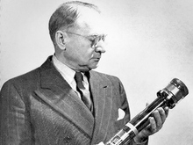 | 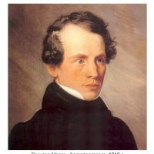 | 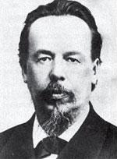
1______________________ | 2___________________________ | 3_______________________
4_______________________ | 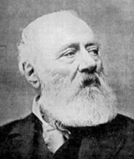  5____________________ | 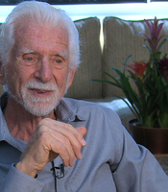  6______________________

Alexander Popov  Antonio Meucci  Martin Cooper | Vladimir Zworykin  Tim Berners- Lee  Samuel Morse
11. Match the communication technologies with their inventors.
radio | Samuel Morse
telephone | Antonio Meucci
the Internet | Alexander Popov
TV | Vladimir Zworykin
telegraph  cell phone | Tim Berners- Lee  Martin Cooper
How would you define the term telecommunication?
Telecommunication is the transmission ….
12. A. Look at the following prefixes and then make your own words.
tele- (=over a distance): e.g. television.
communications, phone, text, working, marketing.
trans- (=across): e.g. transmission
continental, corporation, form, Atlantic.
inter- (=between): e.g. interference
net, active, connections, national, continental.
B. Look at the adjective form of nouns and verbs.
Noun (существительное) or Verb( глагол) + ible (able) = Adjective (прилагательное) e.g. access (доступ) – accessible (доступный), to rely (доверять) – reliable (надежный)
Form adjectives from the following verbs and nouns.
to reuse - _____________________
to dispose - ____________________
to refill - ______________________
to response - ___________________
to consider - ___________________
to practise - _____________________
to achieve - ______________________
13. Complete these sentences with words from 12 A.

(1)________________________ refers to the transmission of signals over a distance for the purpose of communication. Information is (2)_______________ed by devices such as the (3)______________, radio,(4)__________, satellite, or computer networks. Examples could be two people speaking on their mobile phone, a sales department sending a fax to a client, or even someone reading the (5)______________pages on TV. But in the modern world, telecommunications mainly means transferring information across the (6)_______________, via modem, phone lines or wireless networks.
Because of telecommunications, people can now work at home and communicate with their office by computer and telephone. This is called (7)__________________.
It has been predicted that about one third of all work could eventually be performed outside the workplace. In call centres, assistance or support is given to customers using the telephone, email or online chats. They are also used for (8) __________________, the process of selling goods and services over the phone.
14. Find the spellings for these words.
1. |ˈmiːdɪə| - ________________
2. |tranzˈmɪʃ(ə)n| - ___________________
3. |tɛkˈnɒlədʒi| - ___________________
4. |ˈvɪʒ(j)ʊəl| - ___________________
5. |ˈɔːdɪəʊ| - _________________
6. |ˈtʃæn(ə)l| - _________________
7. |ˈsætəlʌɪt| - __________________

15. Read and learn pronunciation of the words from the text “Technology and Communication”.
allow [ə'lau], saturate |ˈsætʃəreɪt|, rely |rɪˈlʌɪ|, variety |vəˈrʌɪəti|, entertainment |ɛntəˈteɪnm(ə)nt|, occur |əˈkəː|, origin |ˈɒrɪdʒɪn|, transmit |tranzˈmɪt| , through |θruː|, evolve |ɪˈvɒlv|, digitized |ˈdɪdʒəˌtaɪzd|, particular |pəˈtɪkjʊlə|, either |ˈʌɪðə|, precursor |prɪˈkəːsə|, though |ðəʊ|, cruiser|ˈkruːzə| notify |ˈnəʊtɪfʌɪ|, relatively |ˈrɛlətɪvli|, simultaneously |ˌsɪmlˈteɪnɪəsli|, capable ['keipabl], mountainous |ˈmaʊntɪnəs|, readjustment |ˌriːəˈdʒʌstmənt|, require |rɪˈkwʌɪə|.
16. Read the text and match the headings (1-6) with the gaps (a-f).
1. Wireless Sound Transmission | 2.Technology Leading to Visual Mass Media | 3. Sound communications | 4. The Internet and Digital Media | 5. Cable and Satellite Television | 6. The real inventor
Technology and Communication
We live in a media-saturated world and rely on a variety of old and new media for information, entertainment, and connection. The beginnings of mass media and mass communication go back 560 years to the “print revolution” that occurred in Europe in the fifteenth century. As we progressed through the centuries, mass communication evolved from a mechanical process to electronic transmission, which paved the way for the digitized world of today.

(a)_____________________________
The origins of sound-based communication, radio in particular, can be traced to the invention of the telegraph. The telegraph was invented in the 1840s and was made practical by Samuel Morse, who invented a system of dots and dashes that could be transmitted across the telegraph cable using electric pulses, making it the first one-to-one communication technology. Messages were encoded to and decoded from dots and dashes on either end of the cable. This first cable could only transmit about six words per minute, but it was the precursor to the global communications network that we now rely on every day. Something else was needed, though, to solve some ongoing communication problems. During this time, war ships couldn’t be notified when wars ended and they sometimes went on fighting for months before they could be located and informed.
(b)________________________________
In May 1895, the Russian physicist, Alexander Popov, reported sending and receiving a wireless signal across a 600 yards distance. In March 1897, Prof. Popov equipped a land station at Kronstadt and the Russian navy cruiser “Africa” with his wireless communications apparatus for ship-to-shore communications.
In about 1900, Popov's wireless apparatus was used in what may have been the first ever use of radio communications to help a vessel in distress. The battleship General Admiral Apraksin was going down amidst the ice floes of the Gulf of Finland with hundreds of sailors and officers aboard, but Popov's radio system enabled them to contact islands 45 kilometers away.
After Popov, the road to radio broadcast was relatively short, as others quickly expanded on his work. Numerous experiments and public demonstrations of radio technology—some more successful than others—were taking place around the same time in the late 1800s and early 1900s.
(c)___________________________________________
And do you know who invented the telephone? The real inventor was Antonio Meucci, a poor Italian American. He shared a workshop with Alexander Graham Bell, and made a “talking telegraph” for his wife who was ill in bed, so that she could call him when she wanted something. But Meucci never took his idea to the US Patent Office, because he was too poor to pay 250$ that he needed.

(d)_________________________________________
As was the case with radio and telephone, several people were simultaneously working to expand the technology that would soon be known as television. In 1884, Paul Nipkow invented a mechanical television-like device that could project a visual image. It took a while for this crude version of a television to be turned into a more functional electronic version. In 1923, Vladimir Zworykin improved on this technology, followed closely by John Baird and Philo Farnsworth. Collectively, these men are responsible for the invention of television, which was the first mass medium capable of instantly and wirelessly transmitting audio and visual signals.
(e)__________________________________________________
Network and broadcast television was forever changed by the growth of cable and satellite technology. Cable was especially attractive to people who lived in mountainous, hilly, or rural areas that had difficulty receiving the broadcast channels’ signals. Many people were also happy to give up ugly rooftop antennae that required readjustment for each channel change.
(f)_________________________________________________
The “Internet and digital media age” began in 1990 and continues today. Tim Berners-Lee is the man who made the Internet functional for the masses. In 1989, Berners-Lee created new computer-programming codes that fixed some problems that were limiting the growth of the Internet as a mass medium. Berners-Lee also invented the first browser, which allowed people to search out information and navigate the growing number of interconnections among computers. Berners-Lee named his new network the “World Wide Web.”
Notes to the text:
ship-to-shore communications – связь между кораблем и берегом
to help a vessel in distress – помочь судну, терпящему бедствие
amidst the ice floes – среди обломков льда

17. Based on the information from the text and your own knowledge decide what these statements are about.
1. It paved the way for radio and television broadcasts.
2. Advances in signal transmission and reception as well as vacuum tube technology made them more reliable and compact.
3. The two types of television began to compete with broadcast television, as they provided access to more channels.
4. The development of digital code, microprocessors, and fiber-optic cables were key technological advances that made it and digital communication possible.
5. It copied many of radio’s ideas and soon displaced the radio as the centerpiece for entertainment in people’s homes.
6. It took advantage of new technologies to become portable and follow people out of their house.

18. Scan the text for the following reference words and phrases and then say what they refer to.
this first cable (para 2)  this time (para 2)  some more successful than others (para 3)  this crude version (para 4) | this technology (para 4)  these men (para 4)  the man (para 6)
19. Work in pairs. Use the words from Essential Vocabulary and from the Text in the correct form to complete the gaps.
attractive take place allow simultaneously in particular require solve though responsible notify

1. The digital technology s___________ the old problems of noise in signal transmission.
2. Where did the survey t______ p_________?
3. T__________ first developed for military purposes, radar can be used in modern cars.
4. One laser beam could carry all the radio, TV and telephone messages s______________.
5. Cable was especially a_________________ to people who lived in mountainous, hilly, or rural areas.
6. Digital TV provides a better quality of picture and sound and a______________ broadcasters to deliver more channels.
7. The equipment r_________________ further improvement.
8. These men are r______________________ for the invention of television, which was the first mass medium capable of instantly and wirelessly transmitting audio and visual signals.
9. He was n____________________ that he did not get the job.
10. This doesn't improve the speed of transport vehicles in general and that of an automobile i____ p_________________.

20. Why are these numbers and dates mentioned in the text? Look back and check, if necessary.
1. 560 2. 1840  5. 1884 6. 1923 | 3. 1895 4. 45  7. 1989 8. 990
21. Summarize the technological advances of the print, audiovisual, Internet and digital technologies using communication Timeline (8-10 sentences).
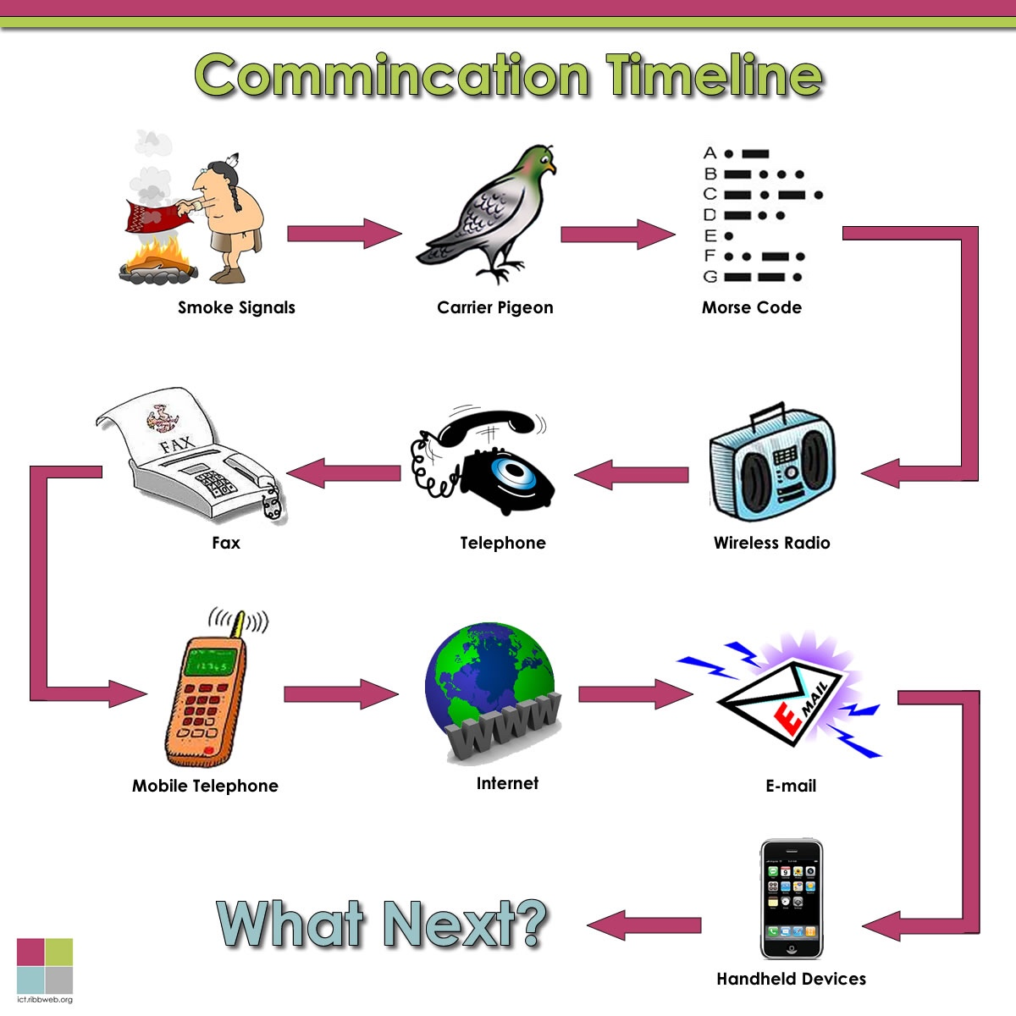
GRAMMAR
Reported questions
- In questions, ask and want to know are common reporting verbs.
In yes/no questions the verb is joined to the reported words with if or whether.
e.g. She asked/wanted to know if (whether) it was true.
In Wh- questions, we do not need if or whether. “Where are my glasses?”
He asked me where his glasses were.
Word order in reported questions:
The reporting verb comes first, then the question word, and then the reported sentence with the tense moved back. And don`t forget to change the word order from question word order to statement word order.
e.g. Who ate the cake? He asked me who had eaten the cake. (He asked me who`d eaten the cake.)

22. Report the next six questions using “He asked…”
1. “What are you doing here?”
e.g. He asked me what I was doing there.
2. “When does the football match start?”
3. “Why didn’t you answer my letter?”
4. “Do you have a blog or read other blogs?”
5. “Can we protect our email and keep it private?”
6. “Is it your new website ?”

23. Put the words into the correct order to make reported questions.
1. The teacher/ when/ asked /the telegraph/ had /invented/ been
2. She asked me /several people /if/ were simultaneously /television technology/ working on
3. TV technician asks /we /receive/ if/ the broadcast channels’ signals/ can
4. He/ if people are / wonders / interested in new invention
5. The students /know/when the first TV set / wanted to /had appeared
6. wonders/ whether / She /are used for/ satellites/ telephone communication

4.3 The Internet and its future.

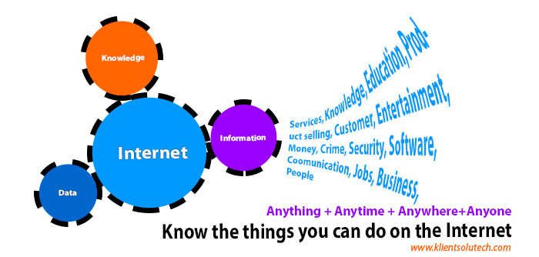

How would you define the Internet?

24. Make a list of things you can use the Internet for.

Underline words in italics which are true to you.

Uses of the Internet | How often do you do this?
Education (using educational websites) | never/ sometimes/ usually/ often/ always
Social networking | never/ sometimes/ usually/ often/ always
Exploring the world (various places on the Earth) | never/ sometimes/ usually/ often/ always
Job hunt (applying for a job) | never/ sometimes/ usually/ often/ always
Shopping (purchasing through a catalog) | never/ sometimes/ usually/ often/ always
Online booking (movies, hotels, concerts, exhibitions, railways and airlines tickets) | never/ sometimes/ usually/ often/ always
Blogging | never/ sometimes/ usually/ often/ always
Sending emails | never/ sometimes/ usually/ often/ always
Online chatting | never/ sometimes/ usually/ often/ always
Video conferencing | never/ sometimes/ usually/ often/ always
Research (looking for facts, information) | never/ sometimes/ usually/ often/ always
Financial transactions (online payment) | never/ sometimes/ usually/ often/ always
Posting messages on forums | never/ sometimes/ usually/ often/ always

25. Work in pairs. Ask your partner questions if he (she) does it on the Internet and how often he (she) does it. Compare with your answers.

e.g. Student A: Do you shop online?

Student B: Oh yes! I really do.

Student A: How often do you buy things online?

Student B: I always do it because buying online is time-saving. Student A: But I`m the opposite! I did it only once – last summer I bought … Note! Useful phrases for finding things in common:

Me too. That`s the same for me.

For finding differences: Oh, I`m the opposite! Really?

26. You will hear a man talking about the Internet (https://listenaminute.com/i/internet.html) Listen and fill in the gaps.
I think the Internet is the greatest _______________________. Think how it has changed the world. So much information is out there. _______________________ changed my life. I can chat with friends, download music, buy books and _______________________ I need for my homework. It took days or _______________________ any of these things before the Internet. I spend hours every day online. I think I _______________________ too long. I’m sure _______________________ computer screen all day isn’t good for my eyes. I think it’s also _______________________. I need to exercise a little more. The only thing I don’t like about the Internet _______________________ be dangerous. I don’t really _______________________ personal information online, especially on _______________________ sites like Facebook.

27. Read the list of points about the Internet advantages and mark them A (advantage) or D (disadvantage).
- offers immediate communication
- cheaper than telephone calls / face-to-face meetings
- people may lose “real” social skills
- allows global communication without the need to travel
- more convenient / people can communicate on-the-move
- people may spend less time socialising face-to-face
- people may become more introverted
- allows friends and family overseas to stay connected
- people spend too much time in front of a screen
- gives everybody the chance to have a public voice
- offers more flexibility for the learner
- people may become addicted to social network sites
- may cause security issues / files may be lost
- breakdowns in the system may cause severe problems
- allows people in rural areas the same study opportunities
- has made some jobs redundant

28. Work in two teams. Team A strongly believes the Internet has more advantages; Team B strongly believes the Internet has several disadvantages and threats. Give reasons for your answer and include any relevant examples from your own knowledge or experience.

29. Answer these questions about the future of the Internet?

1. Will the Internet be faster and more pervasive (распространенный)?

2. Will virtual reality play a major role?

3. What Internet trends do you know?

4. Have you heard of the Internet of Things (IoT)? What is it?

To give your opinion use the following phrases:

From my point of view…

As far as I am concerned….

In my opinion…

As far as I can judge…

I am absolutely sure that…

30. Watch the video “Internet of Things (IoT) Architecture for Beginners”

https://www.youtube.com/watch?v=EcWhxb77Gug
Before watching:
silo – разобщенный
interoperable – взаимодействующий (функционально-совместимый)
framework – модель, шаблон

31. Decide if the following statements are True/False. Correct the wrong ones.
1. The author asks if an orchid will ever be able to tell its story.
2. He wants to know if a tree will one day tell us where it was grown.
3. He wonders whether a car can call the police faster than a phone.
4. He asks if people can automatically deliver important often life-saving data.
5. He wonders whether a patient himself can gather critical information before arriving at the hospital.
6. The narrator asks if it`s possible to teach traffic to speak.
32. Match A with B to make complete sentences.
A | B
1. Do you think it`s possible | a. to connect many different applications in one coherent Network.
2. None of this | b. be broken down into smaller elements.
3. The main challenge is | c. is science fiction.
4. We need to provide devices | d. will talk to us and to each other.
5. All silo components must | e. with a common language.
6. In the future things | f. to teach traffic to speak?

33. Read a short example of the Internet of Things (IoT). Then in pairs/groups brainstorm examples of the IoT
Suppose you wear a smart watch which senses your blood pressure and keeps you aware of it. For instance, your blood pressure level crosses the danger level. So in that case your smart watch will automatically send a message to another smart device installed at your nearest hospital via internet. On receiving such alarming message, they will take a wise decision by sending an ambulance to your address and thus treat you on time. That's the power of IoT.
34. Work in pairs. What are the pros and cons of these things being connected to the Internet? Complete this table with your partner(s). Change partners often and share what you wrote.
e.g. Our refrigerators can notify us prior to milk running out. So, the fridge will simply contact the delivery service when it senses stocks need replenishing (пополнять запасы).
 | Possible uses | Pros | Cons
Your fridge
Your car
Your watch
Your shoes
Your sofa
Your garden

35. Work in pairs. Student A: Read Part A of the text. Then look at the questions and choose the correct alternative (according to the article). Student B: Do the same for Part B.
Part A
A bright outlook
It’s a summer morning in 2040. The internet is all around you and all the things that you’re about to do during your day will fall in to place (вставать на свои места) thanks to the data streams flying across the internet. Public transport in the city dynamically adjusts schedules and routes to remove delays. Buying your kids the perfect birthday presents is easy because their data tells your shopping service exactly what they will want. Best of all, you’re alive despite a near-fatal accident last month because doctors in the hospital’s emergency department had easy access to your medical history.
It sounds good, doesn’t it? This is the future in which data powers everything. It’s an idea that the web’s creator has been pushing now. During a recent appearance in London, he said that we might one day have much greater ownership over the data that belongs to us.
“I would like us to build a world in which I have control of my data, I own it,” he explained. “We’ll be able to write apps which take data from all different parts of my life and my friends’ lives and my family’s lives.”
Questions for Part A
1. Public transport/private transport adjusts schedules and routes to remove delays.
2. Buying your kids the birthday presents is hard/easy because their data tells your shopping service their likes/dislikes.
3. Doctors in the hospital’s emergency department had/did not have easy access to your medical history.
4. This is the future in which data/money powers everything.
5. The web`s creator wants to have control of his data/health.
Part B
Virtual nightmares
It’s a winter evening in 2040 and the world is a darker place. The internet is full of cybercrime and it’s become impossible to go online without making your bank account vulnerable or risking identity theft. Trolls have taken over social networking, the web is madly priced and segmented, meaning only the rich can access the most useful and up-to-date resources. In some countries people’s every move is constantly monitored by secret police using networked sensors and internet communications. Even if you can get online, would you want to?
Hints of the potential for digital catastrophe are spread around the world already. As the New York Times noted, a recent “Pew Research report on the likely nature of the Internet a decade from now” contained the word “threat” more than four times as often as the word “hope”.
Questions for Part B
1. It’s a winter evening in 2040 and the world is a darker/brighter place.
2. You can/cannot enter your online bank account without risking theft.
3. Only the rich/educated people can access the most useful and up-to-date resources.
4. Social media sources/trolls have taken over social networking.
5. The word “threat”/”safety” is often used in the report on the likely nature of the Internet.

36. Tell your story (Part A or Part B) to your partner. What are your visions of the future Internet?

GRAMMAR
Reported orders, advice and requests
- With orders, advice and requests we use the infinitive after the object.
“Call me back later.” She asked him to call her back later.
“Please don`t tell anybody what happened.” He asked me not to tell anybody what (had) happened.
37. Report the next six requests and orders.
1. Father said to his son, “Turn the computer off!”
2. Mother said to her daughter, “Don’t watch these mindless series!”
3. The manager said, “Please switch off your mobiles when the concert starts!”
4. She requested, “Keep the call short.”
5. The teacher advised, “Avoid talking where you may be distracting to others.”
6. The police officer ordered, “Don`t drive and talk on your cell phone”

38. Work in pairs. Student A: Reconstruct the reported speech in the following sentences. Student B: Check up the partner’s answers with the help of the key (look at page 28-29 of the Supplementary section at the end of the Module).

Student A
- Nick said that a famous American actor had come to Moscow the previous week.
- I wonder if the BBC World Service broadcasts throughout the world.
- Jane said that she would advertise a new shampoo on TV.
- He wanted to know when I switched my mobile phone off.
- We were told that emails were usually more informal than letters.
- I had to admit that I had never seen such a controversial programme.
- He asked us to stay with them that night.
- He stated that a plasma television is made up of two sheets of glass.

Now swap the roles. Student B: Reconstruct the reported speech in the following sentences. Student A: Check up the partner’s answers with the help of the key (look at page 28-29 of the Supplementary section at the end of the Module)
Student B
- Linda said that her brother liked to watch crime mysteries.
- Lena said that she hadn`t seen that game show.
- He told me that he was chatting on the phone.
- The teacher asked me which method of communication I used regularly.
- She said she would get herself a mobile phone the following week.
- They were instructed not to use stereo equipment.
- Students wanted to know when satellite television had emerged.
- He asked me whether he should phone her.

4.4 The mobile phone
39. Discuss the following questions:
1. What is your preferred way to communicate with friends: email, telephone, social networks or text messaging?
2. How much time do you spend talking on the phone, texting or sending email?
3. What are the advantages and disadvantages of mobile phones compared to land-lines?
4. What problems can you have when using a mobile phone?
5. What other things can mobile phones be used for apart from just talking to another person?
6. What do we call a mobile phone with advanced functions, providing voice service as well as any combination of email, text messaging, web access, voice recorder, camera, MP3, TV or video player and organizer?
40. Read the article and complete it with smartphone developments from the box.

Five key smartphone developments in 2017

Facial scanning Dual lens cameras Roaming be gone

The ultra-premium handset The end of the home button
It`s been a big year for smartphones. We look back at the latest innovations. Here are the five biggest developments for smartphones over the past months.
1) _________________  The single, front–facing home button has been a cornerstone of smartphone design ever since the original iPhone burst onto the scene in 2007. 10 years on and the need for a physical key on the front of a smartphone had decreased. | 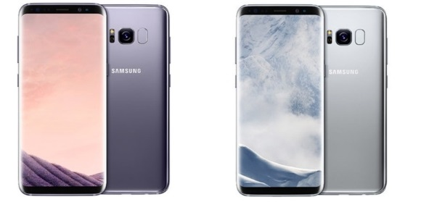
Samsung was the first to switch to an all–screen design with its Galaxy S8, with a fingerprint scanner on the back to make it easy to open the device securely. Apple followed suit with the iPhone X, finally bringing an end to the feature which had made the device stand out from the crowd when it first launched a decade ago.
2) _________________
It isn’t new. But until 2017, it was only ever a niche concern, with enough worries about security and ease of use.
The iPhone X changed that. Having replaced the Touch ID fingerprint scanner, it offered complex, 3D _______mapping, allowing users to unlock their phone and create personalised emoji with just a glance.

3) _________________
In the past twelve years, more and more mobile makers have started offering them to deliver crystal clear images.
Samsung’s Galaxy Note 8 camera offered a superb picture, as did the OnePlus 5 and 5T. The iPhone X and iPhone 8 Plus took this setup from last year’s iPhone 7 Plus and developed it, serving up images of the much better quality than those taken on any other smartphone.
4)
________________________
Good smartphones have never been cheap. But what the previous years have shown is that the biggest names are keen to create a new, super category of devices.

Apple’s iPhone X, costing up to £1,149 SIM–free for a 256GB model, is the most obvious case.
With rumours pointing towards Google offering an ultra-high-end Pixel 3 in 2018, we can expect this trend to grow over the next year.
5) _________________
Roaming’s power over holidaymakers finally ended in 2017, in Europe at least, with the EU ending charges in June. Networks then began to improve their offerings, with Vodafone, Three and EE (telecommunications companies) fighting in their efforts to bring cheaper roaming to countries outside the union.
That has culminated in Three now adding 11 destinations to its Feel At Home programme, meaning 71 places now offering free calls, texts and data for its customers.
Which of these features are new to you? In pairs, describe your mobile phone using the following clues to help you.
- Design (how it looks, colour, weight, LCD screen)
- Built-in camera
- Wireless support
- Keypad
- Ringtone
- Performance and battery life
- Value for money
41. Work with a partner. Check if you are a responsible mobile user.
Student A: 1. Do you switch off your mobile or turn it to vibrate when you are at the lesson, at the cinema or at the theatre?
Student B: (give your answer and reasons)
Student A: 2. Do you shout while you are speaking?
Student B: _________________
Student A: 3. Can you talk as much as you want if you are talking to your friends?
Student B: ___________________
Student A: 4. Do you use your phone while walking?
Student B: _____________

Now swap the roles.
Student B: 5. Can you use your mobile to phone your friends any time, anywhere?
Student A: (give your answer and reasons)
Student B: 6. Do you always pay attention to where you are going because you are talking on a mobile phone?
Student A: ________

Student B: 7. Do you keep your phone ringer as low as possible, so it does not distract the people around you?

Student A: _______

Student B: 8. Would you rather text your friends than actually speak to them in person?

Student A: _______

42. Now summarize what your partner said using reported speech.

e.g. Pavel said that he always switched off his mobile ….

43. Watch the Video “Walking While Texting”
https://www.youtube.com/watch?v=tm2lfv3_ELc
What solution is offered to prevent “texters” from bumping into other people?
Do you think this measure will work in your city?
Useful notes:
In a hustle and bustle- в давке и сутолоке
to be aware of smth –отдавать отчёт, сознавать
shrink – сокращаться, сжиматься
44. Guess the answers.
1 In a hustle and bustle of the street you need to be ______your surrounding.
a. beware of
b. unaware of
c. aware of
d. adware of
2. You were on your phone? That`s a ______________________!
a. dangerously devices
b. dangerous devices
c. dangerous device
d. undangerous device
3. It`s amazing, how many people on their cell-phones____________________ there is a gorilla.
a. having even noticed
b. haven`t even noticed
c. have never noticed
d. haven`t ever noticed
4. I was looking at what my _________________________was.
a. next point
b. next pointer
c. next appointment
d. next appointee
5. Studies have shown that even just talking on your cell phone can reduce your _________________________ .
a. peripheral fission
b. peripheral fusion
c. periphery vision
d. peripheral vision
6. When you`re texting, it can shrink to less than ______ of the normal range.
a. on tenth
b. one tenth
c. one ten
d. won tenth
7. We can get talkers _______________out of everybody else`s way.
a. and taxis
b. and texters
c. end texters
d. end taxi
8. We put arrows onto the ground onto the ___________________.
a. sale phone lane
b. cell phone`s lane
c. cell phone lane
d. cell phone line
45. Work in pairs. Decide when it is not a good idea to talk on a mobile phone or to text and why. Complete this table with your partner and speak on that.
For giving your opinion use the following phrases:
In my opinion,….. From my point of view….. I strongly believe that…… I`m more than sure that…. I think it`s wrong to….
 | OK? | Why?
While crossing a road
On the street
In a shopping mall
On a train
In a restaurant
In a movie/theatre
46. Ask your partner(s) questions by choosing a question starter in the first column with a word or phrase in the second column.
Have you ever…  What do you think of…  Do you…  What kind of…  Have you heard of…  When was the last time…  Could you live without…  Would you like… | mobile phone  Skype  e-mails  spam  phishing  the Internet  future  a higher speed Internet connection  videophone  telephone answering machine  voicemail

47. Have you ever made telephone calls in English? When? What for?
Fill in the gaps with one word to complete the verb phrases.

__________________ | in touch with somebody
contact | somebody
__________________ | somebody
phone | somebody
___________________ | on the phone to somebody
put | someone through to somebody
___________________ | through to somebody
hang | up on somebody
___________________ | somebody back

48. Complete these sentences with the verb phrases from exercise 47.

1. Hello. Mr Johnson is expecting your call. I’ll just_________ (you) __________.
2. I called my friend, but she ____________________to someone.
3. I tried to __________________ to her on the telephone, but I failed.
4. After two years of silence he suddenly __________________ with us again.
5. It was strange but the girl didn`t_________________ and they got chatting.
6. She's having lunch. Can you ______________ later?
49. Work in pairs to complete the telephone conversation. Use the phrases in the box.
Could you ask her to call me Can I speak to
I’m sorry, she’s away today Can I have your number?
Can you spell that, please? Could you give her a message?
Who’s calling, please? Could you tell me your name again?
Hold the line, please.
Receptionist: Good afternoon. Global Travel. How can I help you?
Caller: Hello. ___________(1) Emma Norton, please?
Receptionist:____________(2)?
Caller: It’s George Kimberley.
Receptionist: Thank you. __________(3) I’ll put you through to her office.
Caller: Thank you.
Colleague: Emma Norton’s phone. David Lawson here. Can I help you?
Caller: Oh, this is George Kimberley. Could I speak to Emma, please?
Colleague: _______________(4)
Caller: Oh, I need to speak to her – It’s quite important.
Colleague: Perhaps I can help you.
Caller: Thank you. ______________(5)
Colleague: Yes, of course.
Caller: ____________(6) tomorrow morning?
Colleague: Yes, certainly. ____________(7) , please?
Caller: It’s Kimberley. George Kimberley.
Colleague: _____________(8)
Caller: It’s K-I-M-B-E-R-L-E-Y-.
Colleague: And _____________(9)
Caller: It’s 0-1-6-5-7, 3-double two-5-8-9-0.
Colleague: Right. So that’s Mr George Kimberley on 0-1-6-5-7, 3-double two-5-8-9-0.
Caller: That’s it. Thank you very much. Goodbye.
Colleague: Goodbye.
50. Practice your own telephone talk based on a variety of reasons
e.g. making/changing appointments, asking for someone on the phone, a problem with an internet access, leaving a message to your friend
and proper responses to these situations
e.g. “The doctor is available Tuesday morning”; “He’s at a meeting right now. Would you like to leave a message?”; “I’ll put you through to Technical Assistance”

CONSOLIDATION
1. Put the sentences into reported speech. (2.5 points)
1. “I’ll put you through to the office”, she told me.
She said ________________________________________________________________.
2. “Where did the survey take place? “ she asked the students.
She asked _______________________________________________________________.
3. “I don’t really like putting my personal information online “I said to him.
I told him________________________________________________________________.
4. “Did you enjoy the film?” asked my friend.
My friend asked _________________________________________________________.
5. “Call William tonight!” a text message asked.
A text message asked _____________________________________________________.
2. Complete the sentences with a suitable word in the correct form. (2.5 points)
through evolve in particular origin trace

1. The o____________ of sound-based communication, radio i___ p___________, can be t_________ to the invention of the telegraph.
2. T____________the centuries, mass communication e______________ from a mechanical process to electronic transmission.
3. Complete the table. (1 points)
Verb | Adjective
rely
use
 | accessible
 | traceable

4. Unjumble the words and write two or three more sentences on the given topic.
(4 points)
In fact, without many can't how they people lived (1) a portable phone. However, many people also complain users cell about phone (2). People complain about other people matters loudly discussing public personal places in (3).
They complain when cell phones ____________

Supplementary
Lesson 3
38. Student B
Student B
Key:
- “A famous American actor came to Moscow last week.”
- “Does the BBC World Service broadcast throughout the world?.”
- “I`ll advertise a new shampoo on TV.”
- “When do you switch your mobile phone off?”
- “E-mails are usually more informal than letters.”
- “I have never seen such a controversial programme.”
- “Please, stay with us tonight!”
- “A plasma television is made up of two sheets of glass.”

Student A
Key:
- “My brother likes to watch crime mysteries.”
- “I haven`t seen this game show.”
- “I am chatting on the phone.”
4. “Which method of communication do you use regularly?”
5. “I’ll get myself a mobile phone next week.”
6. “Do not use stereo equipment!”
7. “When did satellite television emerge?”
8. “Shall I phone her?”

References
1. http://www.conferencecallsunlimited.com/history-of-communication-technology/
2. http://learnenglish.britishcouncil.org/en/magazine/mobile-phones
3. https://breakingnewsenglish.com/1504/150428-internet-of-things.html)
4. https://listenaminute.com/i/internet.html
5. http://www.bbc.com/future/story/20141015-will-we-fear-tomorrows-internet

This video can be watched at different speeds. You may adjust the appropriate speed using the icon Adjustment (Настройка)

